Go to the directory where the video is saved

On the thumbnail of the video there is a settings button - click that

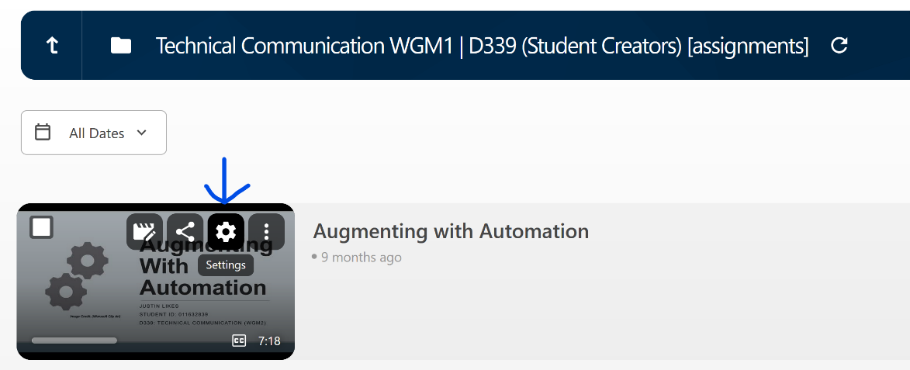

In settings on the Overview tab there is a Folder section, hit Edit at the end of that Folder

Click the dropdown, Click the D479 folder, and click down as far as that directory goes into the Student Creators folder at the bottom and from there I should be able to access it.

Please double check

For the permissions issue, the owner of the video needs to move the file location to be : **User Experience Design HJN1 C856 | D479 Student Creators (see below)**

Make sure you click those arrows

